
B.R.GLOBAL SCHOOL

REPORT ON POCSO ACT AWARENESS WORKSHOP FOR STUDENTS
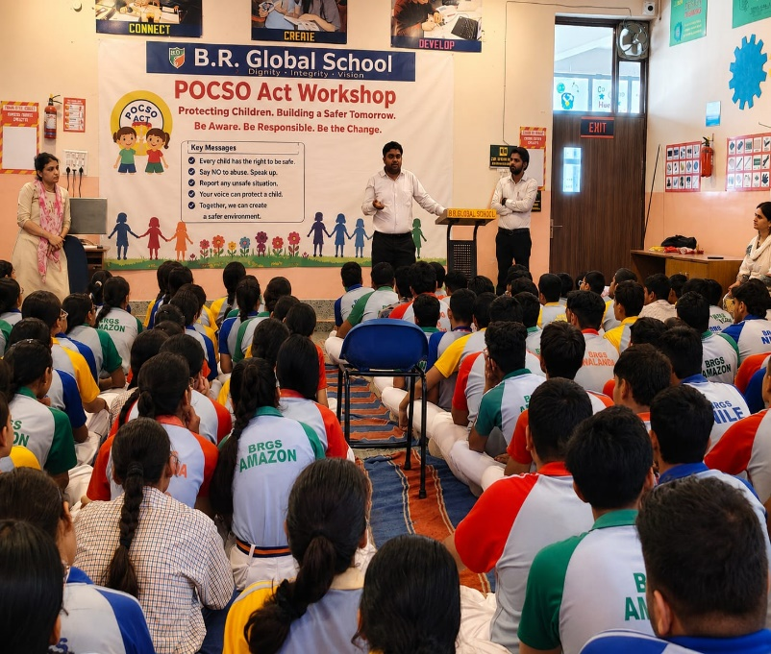
School Name: B.R. Global School
Session: 2026–27
Title: POCSO Act Awareness Workshop for Students
Date: 14 July 2026 and 15 July 2026
Day: Tuesday and Wednesday
Venue: AT Lab
Time: 11:30 am to 2:00 pm
Resource Person:
Mr.Sahil Saroha (Advocate, district Sonepat)
Mr. Subham Goswami (Advocate, district Sonepat)
Ms. Manju Kumari ( Vice Principal),
Ms. Manisha ( PGT ),
Managing committee
Ms. Sonia Rapria (Coordinator X to XII)
Ms. Rachana (Coordinator VI to IX)

Ms.Sunita Arya
Ms. Savita Dahiya

Objective
The workshop was organized to create awareness among students about the Protection of Children from Sexual Offences (POCSO) Act, 2012, Cyber Safety and to empower them with the knowledge and confidence to recognize unsafe situations, understand their rights, and seek timely help from trusted adults.

Introduction
The Protection of Children from Sexual Offences (POCSO) Act, 2012, is a special law enacted by the Government of India to protect children below the age of 18 years from sexual abuse, sexual harassment, and exploitation. The workshop aimed to educate students in an age-appropriate and sensitive manner while promoting a safe, respectful, and secure school environment.

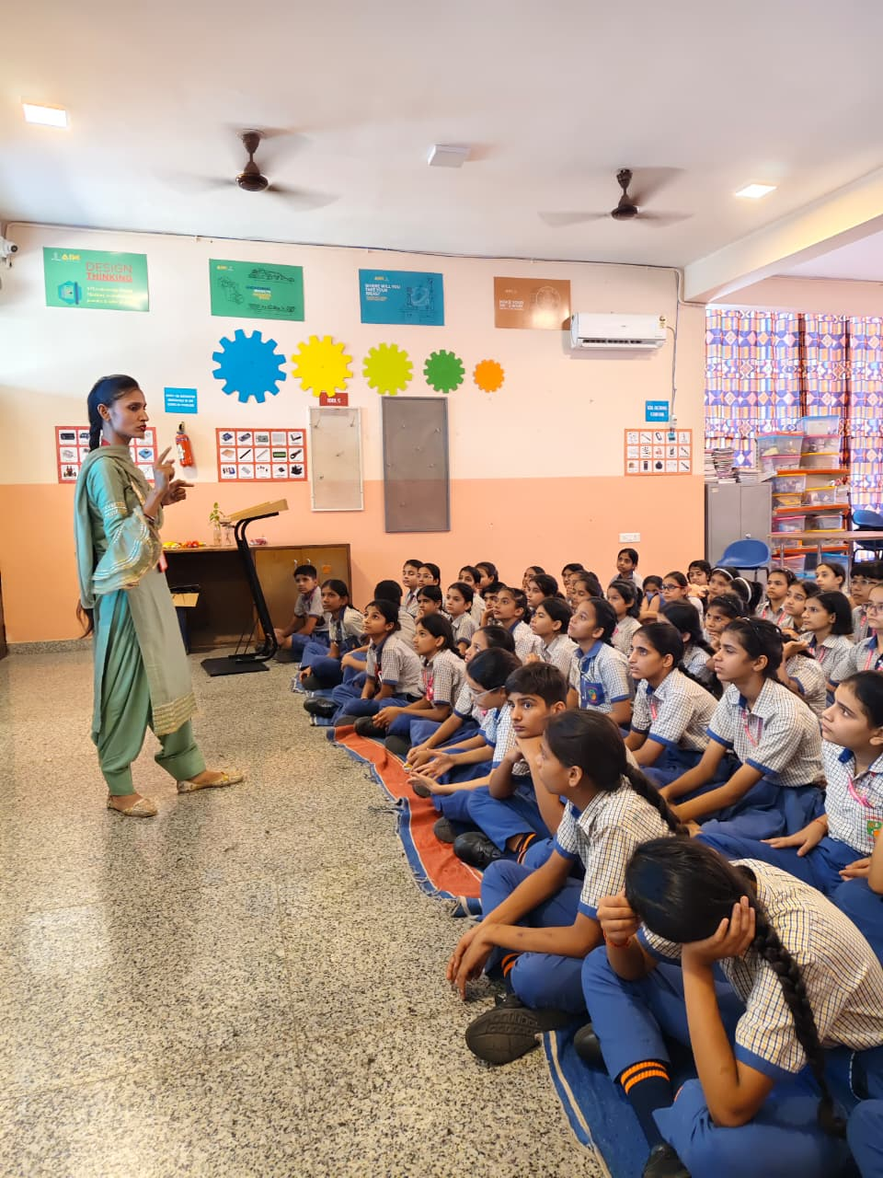
Attendance
Classes 6 to 8
Total No. of students attended: 226
Total teachers attended : 8
Classes 9 to 12
Total no. of students attended: 254
Total teachers attended : 12

Highlights of the Workshop
- Welcome address by the Principal/Vice Principal.
- Introduction to the POCSO Act and its importance.
- Explanation of the concepts of Safe Touch, Unsafe Touch, and Confusing Touch.
- Awareness about personal safety and body boundaries.
- Importance of rule saying “NO”, moving away “GO” from unsafe situations, and “TELL” informing trusted adults.Follow Rule NO-GO-TELL.
- Identification of trusted adults such as parents, teachers, counsellors, and guardians.
- Information about online safety, cyber grooming, and responsible use of social media.
- Discussion on bullying, harassment, and the importance of respecting personal boundaries.
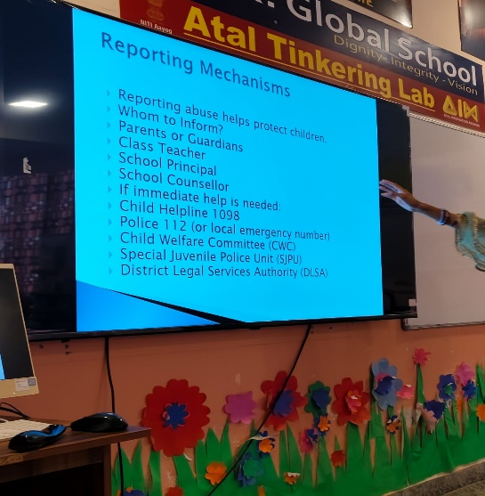
- Awareness regarding the Child Helpline 1098 and reporting mechanisms.
- Interactive question-and-answer session to clarify students’ doubts.
- Students took a pledge to promote a safe, respectful, and caring school environment.

Activities Conducted
- PowerPoint presentation on child safety.
- Interactive discussion with real-life age-appropriate examples.
- Role-play demonstrating safe responses to unsafe situations
- .Safety pledge by all students.

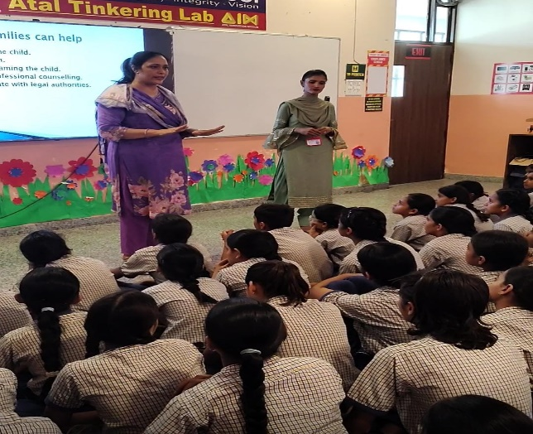
Learning Outcomes
By the end of the workshop, students were able to:
- Understand the purpose of the POCSO Act.
- Differentiate between safe and unsafe touch.
- Recognize unsafe situations and respond appropriately.
- Identify trusted adults and know how to seek help.
- Understand the importance of reporting abuse without fear.
- Demonstrate awareness of online safety and responsible digital behaviour.

Feedback
Students actively participated throughout the session and responded enthusiastically during the interactive activities. They appreciated the practical guidance provided and expressed greater confidence in understanding personal safety and reporting concerns. Teachers also observed that the workshop encouraged open communication and helped reinforce the school’s commitment to child protection.

Conclusion
The POCSO Act Awareness Workshop successfully enhanced students’ awareness regarding child safety, personal boundaries, and their legal rights. The session emphasized that every child has the right to feel safe, respected, and protected. The school remains committed to conducting regular awareness programmes to foster a secure and supportive learning environment for all students.
Prepared By: Verified By: Approved By:
POCSO Committee Vice Principal Principal

